Appendix A1.-2002 Upper Cook Inlet personal use salmon permit.
Vendor Copy | Permit Number: | 02-
2002 Upper Cook Inlet Personal Use Salmon Fishery

Last Name |  |  |  |  |  | First Name |  | Middle Initial
Mailing Address
City |  |  |  | State |  |  | Zip Code
Phone Number: (907)
Total Number of Household members: |  | Total Allowable Harvest: |  |  | You are allowed 25 fish for the head-of-household, and 10 fish for each additional household member. This is your limit for the entire 2002 season.  Example: a family of 4 is allowed 25+10+10+10=55 fish.

2002 Alaska Resident Fishing License Number: |  |  |  |  |  |  |  |  | Drivers License Number:

Signature of permittee (permit holder) |  | Date
Vendor Signature | Vendor Number:
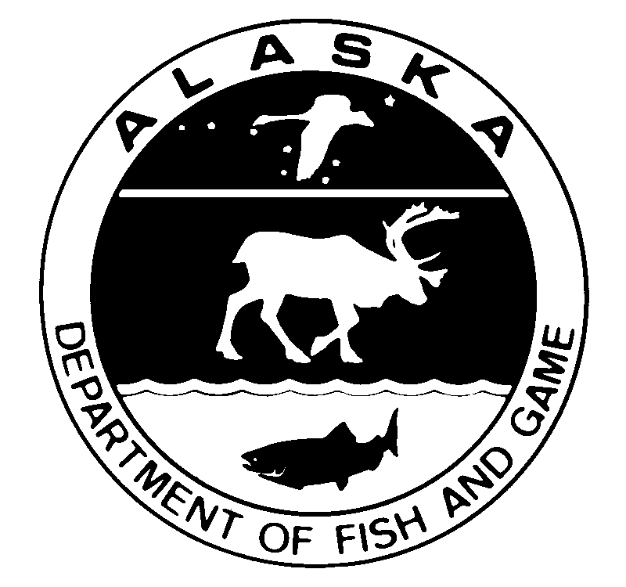
 |  |  |  |  |  |  |  | Permit Number: |  |  | 02-
2002 Upper Cook Inlet Personal Use Salmon Fishery Permit
Last Name |  |  |  |  | First Name |  |  |  |  | Middle Initial
Names of Other Household Members
Total Number of Household members: |  |  | Total Allowable Harvest: |  |  | You are allowed 25 fish for the head-of-household, and 10 fish for each additional household member. This is your limit for the entire 2002 season.  Example: a family of 4 is allowed 25+10+10+10=55 fish.
This permit is for dipnetting at the mouth of the Kasilof and Kenai rivers and Fish Creek (near Wasilla) and for gillnetting near the mouth of the Kasilof River in 2002. You must have this permit with you while you are fishing, and you must record your harvest before you leave the stream. Check the Sport Fishing Regulation Summary for Cook Inlet for legal times, gear, and harvests.
Check this box if no one in your household fished

Report all days fished and all fish harvested. Record every day you fish, even those days when you didn’t catch anything.
Date | Fishery* (see below) |  |  |  |  | RED | chum |  | King |  |  | COHO | Pink
*Fisheries are: Kenai River Dip Net, Kasilof River Dip net, Fish Creek Dip Net, Kasilof River Gill Net
Return this permit to Fish and Game by August 15 2002. You must return your permit even if you did not fish.

Instructions for Vendors
These permits are free, but are for Alaska residents only. To get a permit the person must have a current Alaska resident sport fishing license. Persons who are exempt from licensing (over age 60, under age 16) must have other identification.
These are household permits. Only one permit is issued per household. Each person who fishes must have a current Alaska resident fishing license (unless exempt).
Be sure all the identifying information is complete on the top and bottom of the form. Don’t let people walk out with blank permits!
To Issue a Permit
Ask to see the applicant’s 2002 Alaska resident sport fishing license. Write the license number in the space provided on the top of the form.

Have the applicant fill out his/her name, address, and driver’s license number on the top and bottom of the form, including names of other household members.

Figure out the household’s total allowable harvest. They are allowed 25 fish for the head-of-household and 10 fish for each additional household member. Write it in the space provided on the bottom half of the form. Sign and date the top and write in your vendor number.

Tear the permit along the perforation. You keep the top, the applicant gets the bottom.

Return your top copies each month to Fish and Game in the envelopes provided. After the last fishery closes in early August, return all unissued copies and all the vendor copies to Fish and Game. These must be returned by Sept. 15, 2002.

Address for return of your vendor copies and unissued permits:
State of Alaska, Department of Fish & Game,
Personal Use Salmon Permits,
333 Raspberry Rd,
Anchorage, AK 99518-1599.

Questions? Call the Sport Fishing Information Center at 267-2218.
_________________________
Place
first-class
Postage
Here


_________________________

_________________________

REMOVE BOTH TIPS OF THE TAIL FIN FROM FISH CAUGHT IN PERSONAL-USE FISHERIES

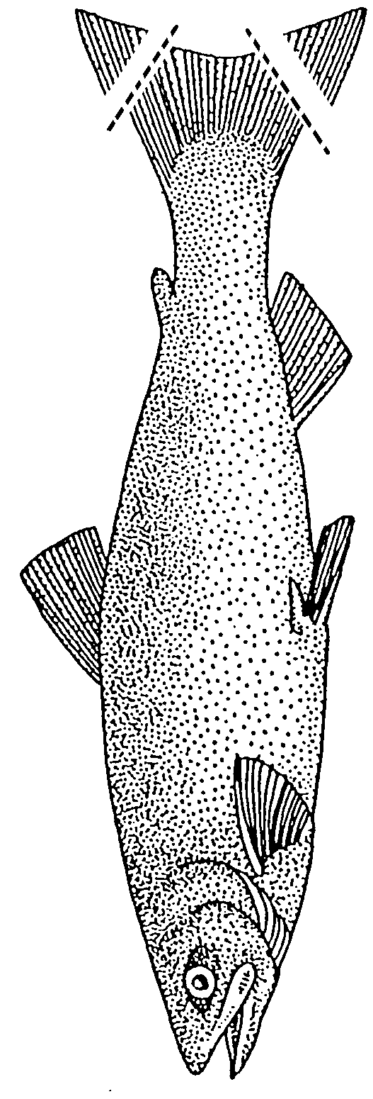STATE OF ALASKA

DEPARTMENT OF FISH AND GAME

Personal Use Salmon Permits
333 raspberry road
Anchorage AK 99518-1599

